# VersaAI: AI Copilot for Product Managers

* Align on goals, scope, and non-goals for a lean MVP.
* Define core personas and user stories tied to real PM workflows.
* Specify prioritized features and UX for a demo-quality hackathon build.
* Outline success metrics and analytics to validate product impact.
* Map high-level architecture, integrations, and constraints for rapid delivery.
* Provide a minimal, fast-moving roadmap and team plan.

### TL;DR

VersaAI reduces the time Product Managers spend drafting PRDs and prioritizing features by generating high-quality documents and data-driven prioritization in minutes. It turns messy inputs (notes, problem statements, user feedback) into structured PRDs, acceptance criteria, and ranked backlogs, ready to export and share. Built for PMs, APMs, Founders, and Business Analysts who need speed, clarity, and stakeholder-ready output.

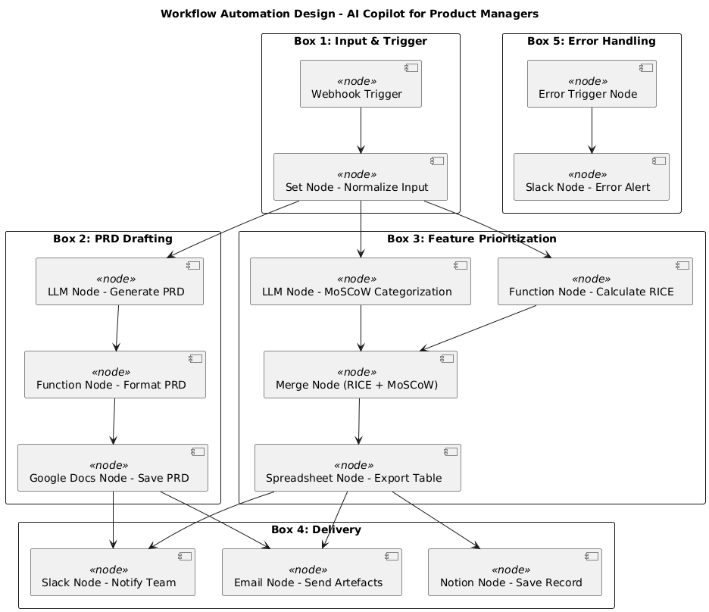

## Goals

### Business Goals

* Reduce time-to-first-PRD by 70% for new users within one session (measured via onboarding analytics).
* Achieve 40% week-1 retention and 25% export conversion for MVP users.
* Secure 50 qualified sign-ups and 15 demo showcases within 2 weeks of launch.
* Maintain CSAT ≥ 4.3/5 for PRD quality and prioritization relevance.
* Deliver a <10-minute end-to-end demo that consistently passes stakeholder review.

### User Goals

* Create a complete, structured PRD from a brief prompt or notes in under 10 minutes.
* Prioritize features using transparent, adjustable criteria (e.g., RICE) with instant re-ranking.
* Export PRDs and backlogs to common tools (Markdown, Google Docs, Jira/CSV) with minimal reformatting.
* Iterate quickly with in-line edits, regenerate sections, and maintain change history.
* Collaborate through links and comments for fast stakeholder alignment.

### Non-Goals

* Enterprise SSO, role-based permissions, and audit trails (out of scope for MVP).
* Deep, bi-directional native integrations (Jira/Confluence/Notion full sync). Use lightweight exports instead.
* Multi-language generation and localization. English-only for hackathon.

## User Stories

* Product Manager (PM)
  + As a PM, I want to paste discovery notes and a problem statement, so that I get a complete PRD draft in minutes.
  + As a PM, I want to pick a prioritization framework (RICE/MoSCoW), so that I can transparently rank features for stakeholders.
  + As a PM, I want to export to Google Docs and Jira/CSV, so that I can share and execute without rework.
  + As a PM, I want to regenerate specific sections (e.g., scope, success metrics), so that I can refine without losing context.
  + As a PM, I want to set constraints (timeline, team size), so that recommendations reflect reality.
* Associate Product Manager (APM)
  + As an APM, I want starter templates for PRDs, so that I can learn best practice structure.
  + As an APM, I want tooltips and examples for each section, so that I understand what “good” looks like.
  + As an APM, I want inline guidance for prioritization inputs, so that I choose sensible values.
* Founder
  + As a Founder, I want a one-page summary and roadmap, so that I can align investors and the team quickly.
  + As a Founder, I want to convert a pitch/problem into a shipping plan, so that I move from vision to execution.
* Business Analyst (BA)
  + As a BA, I want acceptance criteria and measurable success metrics, so that engineering and QA can implement and test.
  + As a BA, I want to attach user/market data to features, so that prioritization reflects evidence.

## Functional Requirements

* AI Authoring (Priority: High) -- PRD Drafting: Generate end-to-end PRD from prompt, notes, or brief form (problem, users, goals, constraints). -- Section Regeneration: Regenerate or refine specific sections while preserving context. -- Tone & Depth Controls: Toggle executive summary vs. detailed spec levels.
* Prioritization Engine (Priority: High) -- Framework Selection: Choose RICE or MoSCoW; expose formula and weights. -- Criteria Inputs: Capture Reach, Impact, Confidence, Effort with guidance and ranges. -- Auto-Ranking & What-If: Re-rank in real time and adjust weights for scenario planning.
* Input/Output & Collaboration (Priority: Medium) -- Imports: Paste text, upload simple .txt/.md, or link notes (copy-paste for hackathon). -- Exports: One-click exports to Markdown, Google Docs, and CSV (for Jira import). -- Shareable Links: View-only public link with optional comment mode.
* Onboarding & Templates (Priority: Medium) -- PRD Templates: SaaS feature PRD, API feature PRD, and mobile feature PRD. -- Guided Onboarding: 3-step wizard with example inputs and inline tips.
* Integrations (Priority: Low) -- Lightweight Jira/CSV Export: Generate CSV with fields for backlog import. -- Google Docs Export: Create document via API or copy-ready output.
* Admin & Security (Priority: Low) -- Basic Auth: Email + password or magic link. -- Data Controls: Local-only project storage; delete project option.

## User Experience

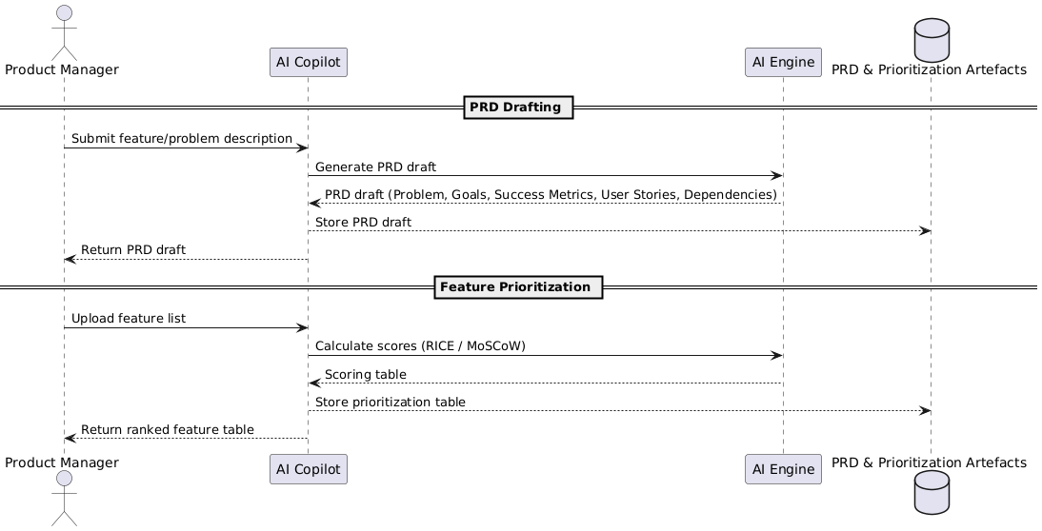

**Entry Point & First-Time User Experience**

* Users discover via link (portfolio site, hackathon page) or invite.
* Landing shows a concise value prop, 90-second demo, and “Start Free.”
* Onboarding wizard requests: product type, target user, problem statement, constraints (team size, timeline).
* Sample project available for instant try-before-input.

**Core Experience**

* Step 1: Create New Project
  + Prominent “New Project” CTA; choose template or blank.
  + Validate minimum input: problem statement ≥ 140 chars, target user, desired outcome.
  + Success: moves to input workspace; show checklist of required items.
* Step 2: Provide Inputs
  + Paste notes or fill guided fields (users, pain points, goals, constraints).
  + Validation: warn on missing critical fields; allow proceed with defaults.
  + Option to attach evidence snippets to features later.
* Step 3: Generate PRD
  + Click “Generate PRD”; show progress with outline preview.
  + Error handling: retry option, show actionable error tips if generation fails.
  + Success: populated PRD with sections (Problem, Goals, Scope, User Stories, Requirements, UX, Metrics).
* Step 4: Edit & Regenerate Sections
  + Inline editing; “Improve” and “Regenerate” per section with change preview.
  + Show diff before accepting; maintain version history per section.
  + Indicate success with toast and version timestamp.
* Step 5: Prioritize Features
  + Switch to Prioritization tab. Enter criteria values (Reach, Impact, etc.).
  + Real-time ranking; edit weights; scenario presets (Speed, Impact, Confidence).
  + Validation: ranges 0–10; surface confidence notes.
  + Success: ranked backlog with rationale and effort bands.
* Step 6: Export & Share
  + Choose export format: Markdown, Google Doc, CSV.
  + Pre-export preview with formatting checks and metadata.
  + Success: copy link or download; show “next steps” checklist.
* Step 7: Review & Iterate
  + Comment mode on share link; resolve comments and regenerate sections.
  + Save states; “Duplicate project” for variants.

**Advanced Features & Edge Cases**

* Long Inputs: Chunking with progress; advise trimming if above limit.
* Ambiguous Prompts: Ask clarifying questions; provide default assumptions.
* Hallucination Guardrails: Cite assumptions and mark speculative content.
* Timeouts/Failures: Auto-retry once; keep user inputs intact.
* Empty Framework Inputs: Provide default values with low confidence flag.
* Offline/No Auth Demo: Read-only sample accessible without login.

**UI/UX Highlights**

* Clear section hierarchy, sticky outline, and keyboard navigation.
* Inline guidance with examples; hover tooltips on criteria fields.
* Accessibility: high-contrast theme, focus states, screen reader labels, minimum 16px fonts.
* Responsive layout optimized for laptop screens; printable/exportable styles.
* Transparent formulas for prioritization; visible weights and rationale.

## Narrative

On Monday morning, Maya, a Product Manager at a growing SaaS startup, faces a familiar crunch: a leadership review on Wednesday with no finalized PRD or prioritized backlog. Her discovery notes are scattered across documents, and engineering needs clarity to estimate effort.

Maya opens VersaAI, selects the SaaS PRD template, and pastes her notes, problem statement, and constraints—a two-sprint timeline and a two-engineer team. In minutes, VersaAI drafts a structured PRD: crisp goals, user stories grounded in her inputs, scope with acceptance criteria, and success metrics aligned to activation and retention. Maya refines the scope with inline edits and regenerates the risks section for added specificity.

Switching to the Prioritization tab, she selects RICE, adds quick estimates for reach, impact, confidence, and effort, and watches the backlog re-rank instantly. She toggles a “Speed” scenario for the near-term milestone and exports the PRD to Google Docs and the backlog to CSV for Jira import. With a shareable link, design, engineering, and leadership comment directly on the document. Maya addresses feedback and regenerates two sections, preserving change history.

By Wednesday, Maya presents a clear plan backed by rationale. Engineering begins grooming with aligned acceptance criteria, leadership approves the milestone, and the team moves fast. VersaAI turns chaos into clarity—saving days of work, improving stakeholder confidence, and accelerating time to impact.

## Success Metrics

* Time-to-First-PRD: Median minutes from project creation to first complete PRD (target ≤ 10 min).
* Export Conversion: % of projects with at least one export (target ≥ 25%).
* Prioritization Usage: % of projects using RICE/MoSCoW and generating a ranked backlog (target ≥ 50%).
* PRD Quality CSAT: Post-export rating ≥ 4.3/5.
* Week-1 Retention: Users returning within 7 days (target ≥ 40%).

### User-Centric Metrics

* Onboarding completion rate ≥ 70%.
* Average number of section regenerations per project (target 2–4 indicating iteration).
* Share link engagement: at least 1 external viewer for 30% of projects.

### Business Metrics

* Qualified sign-ups: 50+ within 2 weeks.
* Demo/showcase count: 15+ credible demos.
* Cost per qualified signup: maintain <$10 (for small paid campaigns if used).

### Technical Metrics

* P95 PRD generation time ≤ 12 seconds.
* Uptime ≥ 99% during demo windows.
* Error rate on generation requests ≤ 2%.

### Tracking Plan

* Events: project_created, onboarding_completed, prd_generated, section_regenerated, prioritization_used, weights_adjusted, export_started, export_completed, share_link_created, comment_added, error_shown, retry_clicked.
* Properties: input_length, template_type, framework_selected, generation_time_ms, export_format, team_size_constraint.
* Funnels: project_created → prd_generated → prioritization_used → export_completed.
* Cohorts: first-time vs. returning users; template type by conversion.

## Technical Considerations

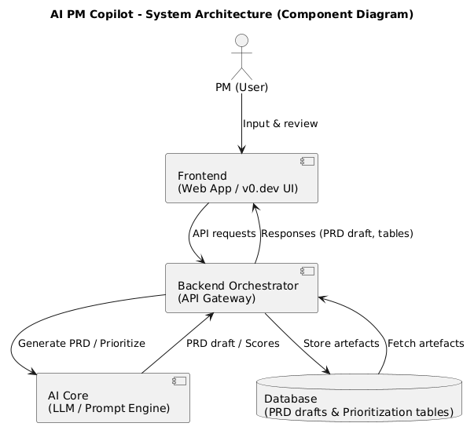

### Technical Needs

* Front-End: Web app with onboarding wizard, editor (sectioned content), prioritization UI, export modals.
* Back-End API: Project/session management, prompt orchestration, scoring engine, export formatting, link sharing.
* AI Core: Prompt templates, section-specific regeneration, rationale scaffolding, prioritization explanation.
* Data Models: Project, Section (versioned), Feature, Criteria, Scenario, Export.
* Observability: Request logging, metrics, error tracking.

### Integration Points

* Google Docs (export) or copy-ready Markdown for portability.
* Jira via CSV import format; instructions and mapping provided in-product.
* Optional: simple webhook for saving exports to Drive/Notion (post-MVP).

### Data Storage & Privacy

* Store projects and section versions; user-controlled delete.
* No training on private data; isolate per user.
* Log metadata (durations, counts) but not sensitive content in analytics.
* Comply with basic data protection norms; clear privacy notice.

### Scalability & Performance

* Expected load: 100–500 users during demo week; bursty traffic during showcases.
* Caching of prompt templates and partial results; guardrails on input size.
* Queue long-running tasks; graceful fallbacks with retries.

### Potential Challenges

* Quality variance in generation; mitigated with guided inputs and examples.
* Hallucinations or speculative claims; mitigated by assumptions callouts and edit-first workflow.
* Third-party export reliability; provide copy-to-clipboard and fallback downloads.
* Tight timelines; de-scope deep integrations and enterprise features.

## Milestones & Sequencing

### Project Estimate

* Small: 1–2 weeks for hackathon-quality MVP with PRD generation, prioritization, and exports.

### Team Size & Composition

* Small Team: 2 total people
  + 1 Product/Full-Stack Engineer (PM + FE/BE + prompt design).
  + 0.5 Designer (part-time for UX polish and visuals).

### Suggested Phases

**Phase 0: Validate & Frame (0.5 day)**

* Key Deliverables: PM/Engineer — value proposition, target personas, example inputs/outputs, success metrics.
* Dependencies: None.

**Phase 1: PRD Generation MVP (3 days)**

* Key Deliverables: PM/Engineer — onboarding wizard, project model, PRD generation with editable sections, section regeneration, sample template.
* Dependencies: Prompt templates finalized; basic UI scaffold.

**Phase 2: Prioritization Engine (2 days)**

* Key Deliverables: PM/Engineer — RICE + MoSCoW selection, criteria inputs, real-time ranking, weight adjustments, scenario presets.
* Dependencies: Feature list extracted from PRD sections.

**Phase 3: Export & Sharing (1 day)**

* Key Deliverables: PM/Engineer — Markdown/Google Doc export, CSV for Jira, shareable read-only link with comment mode.
* Dependencies: Stable document structure.

**Phase 4: Polish & Demo Readiness (1–2 days)**

* Key Deliverables: Designer/PM — onboarding tips, empty states, error handling, analytics events, 10-minute live demo script and sample project.
* Dependencies: MVP features complete; tracking integrated.

### WireFrames

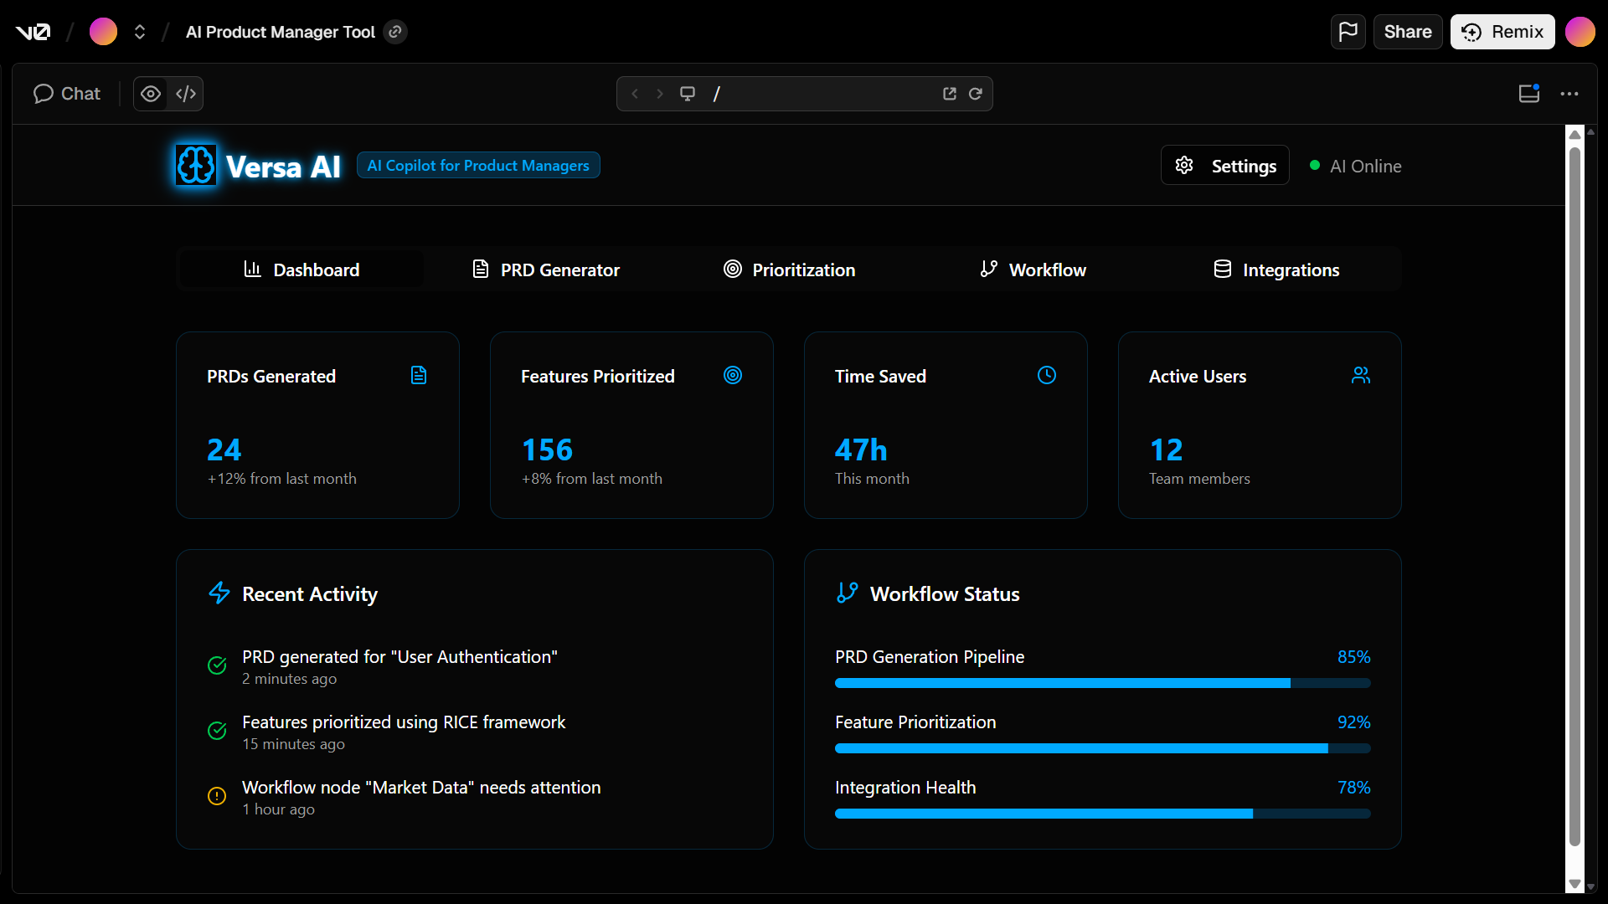

Link Repository: [VersaAI - WireFrames](https://github.com/Fashich/VersaAI)

**Link to the Working Prototype**

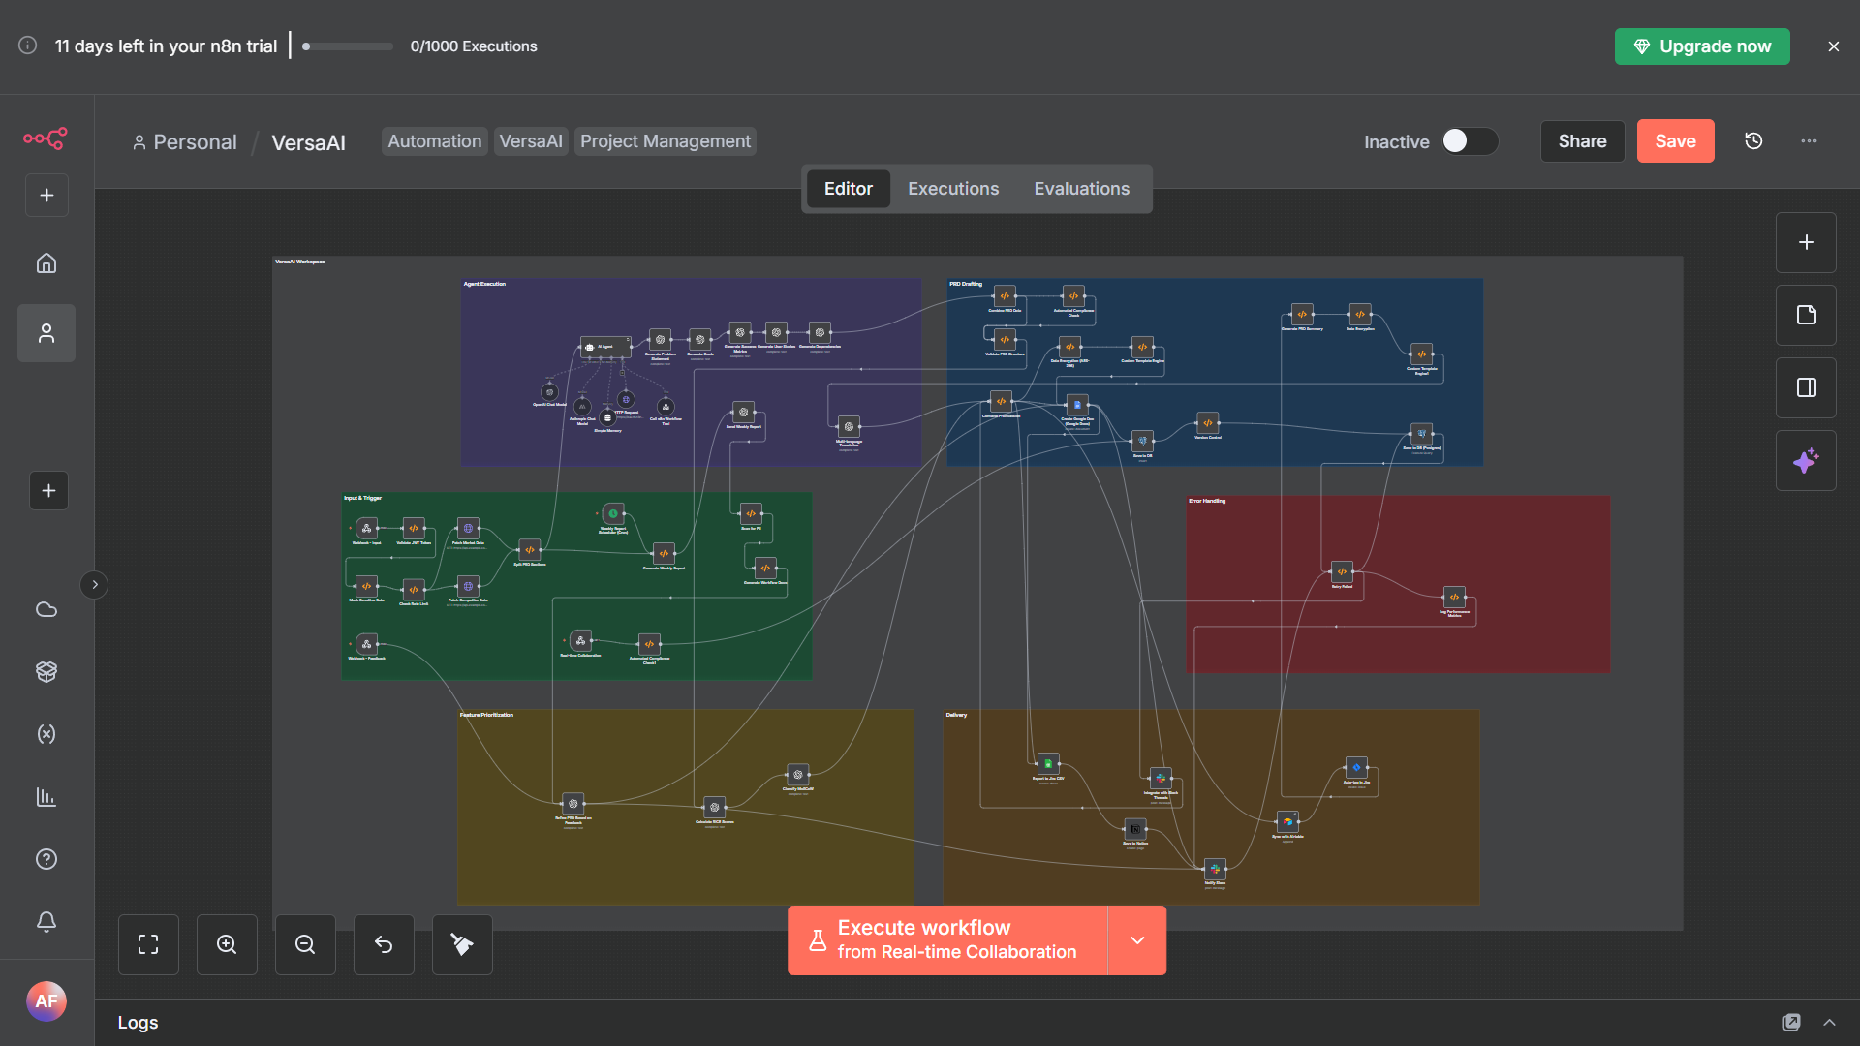

Link Drive: [VersaAI - Drive](https://drive.google.com/drive/folders/1oX_vONfqw7tzM6OtpvDACPGECACVp5q8?usp=sharing) (Other)

Link WireFrames Project: [VersaAI - WireFrames Project](https://drive.google.com/file/d/1i0OoTsQNtBeXOhF5SUnSNiJFhUnME_ow/view?usp=drive_link)

Link File Json: [VersaAI - Project n8n](https://drive.google.com/file/d/1NFeP-Doc5MaFG2VIZVlvwyFk7rtf0Hri/view?usp=drive_link)

Link Credential and Node List: [VersaAI - List](https://drive.google.com/file/d/1CgyXvp1o4jdTQYwqq7LbU_XJ565pjNFI/view?usp=sharing)

Link PRD: [VersaAI - PRD](https://drive.google.com/drive/folders/1K-FZhMa3TDf6dW8O5yc_yV69My6k5Prt?usp=sharing)

**Documentation WorkFlow:**

**Webhook Trigger**

The Webhook Trigger node serves as the primary entry point for all incoming requests to the VersaAI system. This node is configured to listen at the path "/vibeathon/prd" with POST method, enabling secure and structured data ingestion from external sources. The response mode is set to "onReceived" with immediate response handling, ensuring efficient processing without blocking the client. This node validates incoming requests before passing them to subsequent authentication and processing layers, forming the foundational connection point for the entire workflow. The webhook is designed to handle JSON payloads containing problem statements, target users, and constraints, making it the critical interface between external systems and the VersaAI engine.

**JWT Authentication**

The JWT Authentication node implements robust security measures by verifying JSON Web Tokens embedded in authorization headers. This node extracts the token from incoming requests, validates its signature, checks expiration dates, and decodes payload information to establish user identity. The authentication process follows industry-standard practices for secure API access, ensuring only authorized users can interact with the VersaAI system. This node serves as the first line of defense against unauthorized access and potential abuse, implementing strict validation protocols that include token structure verification, algorithm validation, and payload parsing. The output of this node includes authenticated user context information that propagates through the workflow for subsequent processing.

**Data Masking**

The Data Masking node implements comprehensive privacy protection measures by identifying and redacting personally identifiable information (PII) from incoming data. This node employs advanced regular expressions to detect and anonymize email addresses, phone numbers, national ID patterns, and other sensitive data elements. The masking process operates recursively across all JSON properties, ensuring no sensitive information remains exposed in the workflow. This node is critical for GDPR compliance and data privacy regulations, transforming potentially sensitive user inputs into anonymized versions while preserving data structure and usability for subsequent processing stages. The masked data is then passed to the rate limiting and enrichment phases for further processing.

**Rate Limiting**

The Rate Limiting node implements sophisticated traffic management protocols to prevent system abuse and ensure fair resource allocation. This node tracks usage patterns per user identifier, implementing daily request quotas with configurable limits. The node maintains persistent storage for usage counters, resetting them daily while providing detailed metrics about current usage status. This node includes robust error handling that immediately terminates requests exceeding predefined thresholds, returning clear error messages with actionable guidance. The rate limiting implementation is designed to be scalable, efficient, and configurable, ensuring system stability under varying load conditions while maintaining optimal performance for legitimate users.

**Fetch Market Data**

The Fetch Market Data node implements a critical data enrichment capability by retrieving real-time market intelligence from Alpha Vantage API. This node constructs dynamic API requests based on input parameters, executes HTTP GET requests with appropriate authentication headers, and processes the response into structured data formats. The node handles various edge cases including API rate limits, network errors, and invalid responses, implementing automatic retry mechanisms and fallback strategies. The market data retrieved includes comprehensive company overviews, financial metrics, and industry benchmarks that enrich the product requirement document with contextual business intelligence. This node ensures the VersaAI system can provide data-driven recommendations grounded in real market conditions.

**Fetch Competitor Data**

The Fetch Competitor Data node implements a sophisticated competitive intelligence capability by retrieving competitor analysis from specialized market intelligence APIs. This node dynamically constructs API requests based on product names and market segments, executes secure HTTP requests, and processes complex JSON responses into structured data formats. The node includes robust error handling for API failures, rate limiting, and data validation, ensuring reliable data retrieval even under challenging network conditions. The competitor data retrieved includes feature comparisons, market positioning, pricing strategies, and customer sentiment analysis that significantly enhance the quality and relevance of product requirement documents. This node ensures VersaAI can provide strategic recommendations informed by competitive landscape analysis.

**Split PRD Sections**

The Split PRD Sections node implements advanced text parsing capabilities to intelligently divide unstructured input into structured PRD components. This node analyzes incoming text using sophisticated pattern recognition algorithms to identify common PRD sections including problem statements, goals, success metrics, user stories, and dependencies. The node employs natural language processing techniques to detect section headers and content boundaries, even when formatting is inconsistent or incomplete. The output is structured as a well-organized JSON object containing clearly separated PRD components, ready for specialized processing by subsequent AI nodes. This node ensures the VersaAI system can effectively transform messy, unstructured inputs into well-organized components suitable for professional PRD generation.

**Generate Problem Statement**

The Generate Problem Statement node implements sophisticated AI capabilities for crafting precise, professional problem statements. This node utilizes OpenAI's gpt-4-turbo model with carefully crafted prompts that incorporate market data and competitor analysis to generate concise, impactful problem statements. The node applies strict constraints including sentence length limits, professional tone requirements, and contextual relevance checks to ensure the generated problem statements meet industry standards. The node processes inputs through multiple validation stages including grammar checking, clarity assessment, and stakeholder relevance scoring to produce problem statements that effectively communicate the core business challenge in a compelling manner. This node ensures VersaAI can generate problem statements that resonate with technical and business stakeholders alike.

**Generate Goals**

The Generate Goals node implements advanced AI capabilities for creating SMART (Specific, Measurable, Achievable, Relevant, Time-bound) goals. This node utilizes OpenAI's gpt-4-turbo model with precise prompt engineering to transform problem statements into quantifiable business objectives. The node enforces strict formatting requirements including measurable metrics, baseline values, target values, and clear deadlines for each goal. The node applies sophisticated validation checks to ensure goals align with business context, are achievable within constraints, and directly address the identified problem. The output is structured as a JSON array of well-defined goals that serve as the foundation for subsequent success metrics and user stories. This node ensures VersaAI can generate goal statements that effectively guide product development and stakeholder alignment.

**Generate Success Metrics**

The Generate Success Metrics node implements advanced AI capabilities for creating quantifiable success criteria. This node utilizes OpenAI's gpt-4-turbo model with specialized prompting to transform business goals into measurable success metrics. The node enforces strict requirements including quantifiable metrics, baseline measurements, target values, calculation methodologies, and timeframes for each metric. The node applies sophisticated validation checks to ensure metrics are directly tied to business goals, are technically feasible to measure, and provide clear indicators of product success. The output is structured as a JSON array of well-defined metrics that serve as the foundation for product evaluation and stakeholder reporting. This node ensures VersaAI can generate metrics that effectively measure product impact and drive data-driven decision making.

**Generate User Stories**

The Generate User Stories node implements sophisticated AI capabilities for creating comprehensive user stories with acceptance criteria. This node utilizes OpenAI's gpt-4-turbo model with specialized prompting to transform problem statements and goals into well-structured user stories following the "As a [user], I want [feature] so that [benefit]" format. The node enforces strict requirements including clear acceptance criteria for each story, appropriate level of detail, and alignment with business goals. The node applies sophisticated validation checks to ensure stories are actionable, testable, and directly address user needs. The output is structured as a JSON array of user stories with detailed acceptance criteria, serving as the foundation for development and testing activities. This node ensures VersaAI can generate user stories that effectively guide development and ensure product meets user needs.

**Generate Dependencies**

The Generate Dependencies node implements advanced AI capabilities for identifying technical and organizational dependencies. This node utilizes OpenAI's gpt-4-turbo model with specialized prompting to analyze problem statements and generate comprehensive dependency lists. The node enforces strict requirements including clear identification of technical components, team responsibilities, resource requirements, and effort estimation (low/medium/high). The node applies sophisticated validation checks to ensure dependencies are realistic, actionable, and directly tied to the product requirements. The output is structured as a JSON array of dependencies with detailed descriptions and estimated effort levels, serving as the foundation for project planning and resource allocation. This node ensures VersaAI can generate dependency lists that effectively guide project execution and risk management.

**Combine PRD Data**

The Combine PRD Data node implements sophisticated data integration capabilities to consolidate all PRD components into a unified structure. This node processes outputs from all preceding AI generation nodes, validating data integrity and consistency across sections. The node applies structured data formatting to ensure uniform presentation of problem statements, goals, success metrics, user stories, and dependencies. The node includes comprehensive validation checks to ensure all required sections are present and properly formatted, with appropriate timestamps and metadata for version control. The output is structured as a comprehensive JSON object containing all PRD components in a standardized format, ready for structural validation and export operations. This node ensures VersaAI can present a complete, consistent PRD that meets professional standards for product documentation.

**Validate PRD Structure**

The Validate PRD Structure node implements rigorous data quality checks to ensure the integrity of the complete PRD document. This node performs comprehensive structural validation of all PRD components, verifying the presence and format of critical sections including problem statements, goals, success metrics, user stories, and dependencies. The node applies strict validation rules including content length requirements, data type consistency, and section completeness checks. The node includes sophisticated error handling that immediately identifies missing or malformed sections, providing actionable feedback for correction. The output includes detailed validation results indicating any structural issues that need to be addressed before proceeding to prioritization and export operations. This node ensures VersaAI can deliver PRDs that meet professional standards for completeness and quality.

**Calculate RICE Scores**

The Calculate RICE Scores node implements advanced AI capabilities for objective feature prioritization using the RICE framework. This node utilizes OpenAI's gpt-4-turbo model with specialized prompting to analyze user stories and calculate quantitative scores for Reach, Impact, Confidence, and Effort. The node enforces strict scoring ranges (1-10) with clear rationale requirements for each score component. The node applies sophisticated validation checks to ensure scores are consistent, realistic, and directly tied to business impact. The output is structured as a JSON array of scored user stories with detailed rationale for each score component, serving as the foundation for prioritization decisions. This node ensures VersaAI can generate objective, data-driven prioritization that reduces subjective bias in feature selection.

**Classify MoSCoW**

The Classify MoSCoW node implements advanced AI capabilities for feature categorization using the MoSCoW prioritization framework. This node utilizes OpenAI's gpt-4-turbo model with specialized prompting to analyze user stories and categorize them into Must Have, Should Have, Could Have, and Won't Have classifications. The node enforces strict categorization rules with clear justification requirements for each classification decision. The node applies sophisticated validation checks to ensure classifications align with business priorities and technical constraints. The output is structured as a JSON array of categorized user stories with detailed justification for each classification, providing clear guidance for development planning. This node ensures VersaAI can deliver clear, actionable prioritization that aligns with business objectives and technical realities.

**Combine Prioritization**

The Combine Prioritization node implements sophisticated data integration capabilities to merge RICE scores and MoSCoW classifications into a unified prioritization framework. This node processes outputs from both prioritization nodes, calculating total prioritization scores using the formula (Reach + Impact + Confidence) / Effort. The node applies sophisticated data merging algorithms to ensure consistent presentation of prioritization metrics across all features. The node includes comprehensive validation checks to ensure score calculations are accurate and properly formatted. The output is structured as a comprehensive JSON object containing all prioritization metrics in a standardized format, ready for export operations. This node ensures VersaAI can deliver unified prioritization that combines quantitative and qualitative assessment for optimal decision making.

**Create Google Docs**

The Create Google Doc node implements sophisticated document generation capabilities for creating professional PRDs in Google Docs format. This node utilizes Google Docs API with structured Markdown formatting to transform prioritization data into visually appealing, professional documents. The node applies precise formatting rules including section headers, tables, and consistent styling to ensure documents meet professional standards. The node includes comprehensive error handling for API failures, authentication issues, and formatting errors, implementing automatic retry mechanisms and fallback strategies. The output includes a direct link to the generated document in Google Docs, along with metadata about the document creation process. This node ensures VersaAI can deliver professional, shareable PRDs that meet stakeholder expectations for documentation quality.

**Export to Jira CSV**

The Export to Jira CSV node implements sophisticated data export capabilities for creating Jira-compatible backlog files. This node processes prioritization data into CSV format with precise field mapping for Jira import requirements. The node applies strict formatting rules including issue type, summary, description, priority, and story points fields to ensure compatibility with Jira systems. The node includes comprehensive data validation checks to ensure CSV structure meets Jira import specifications. The output includes a downloadable CSV file ready for direct import into Jira backlogs, with metadata about the export process. This node ensures VersaAI can deliver seamless integration with Jira for efficient backlog management and sprint planning.

**Save to Notion**

The Save to Notion node implements sophisticated data storage capabilities for preserving PRD artifacts in Notion databases. This node utilizes Notion API with structured property mapping to transform PRD data into Notion database records. The node applies precise formatting rules for Notion properties including title, status, link, and priority score fields. The node includes comprehensive error handling for API failures, authentication issues, and data mapping errors, implementing automatic retry mechanisms and fallback strategies. The output includes direct links to the saved Notion records, along with metadata about the storage process. This node ensures VersaAI can deliver persistent storage of PRDs in a collaborative workspace that meets team workflow requirements.

**Notify Slack**

The Notify Slack node implements sophisticated communication capabilities for sharing PRD updates with team channels. This node utilizes Slack API with structured message formatting to deliver professional notifications about PRD generation. The node applies precise formatting rules including emoji usage, link rendering, and clear section separation to ensure messages are visually appealing and easily digestible. The node includes comprehensive error handling for API failures, authentication issues, and message formatting errors, implementing automatic retry mechanisms and fallback strategies. The output includes delivery confirmation of Slack notifications, along with metadata about the communication process. This node ensures VersaAI can deliver timely, professional updates to team channels that support effective collaboration.

**Save to DB (PostgreSQL)**

The Save to DB node implements sophisticated database storage capabilities for preserving PRD versions in PostgreSQL. This node utilizes PostgreSQL API with structured query execution to transform PRD data into persistent database records. The node applies precise schema mapping rules for user_id, prd_data, and created_at fields to ensure data integrity. The node includes comprehensive error handling for database failures, connection issues, and query errors, implementing automatic retry mechanisms and fallback strategies. The output includes confirmation of database storage operations, along with metadata about the storage process. This node ensures VersaAI can deliver persistent storage of PRDs in a reliable, scalable database system that meets enterprise requirements.

**Version Control**

The Version Control node implements sophisticated data versioning capabilities for tracking changes to PRDs over time. This node processes current PRD data against previous versions to identify differences and changes. The node applies sophisticated diff algorithms to compare specific sections, metrics, and prioritization scores between versions. The node includes comprehensive validation checks to ensure version differences are accurately captured and documented. The output includes detailed version history information with change summaries, allowing for easy tracking of PRD evolution over time. This node ensures VersaAI can deliver comprehensive version control that supports iterative product development and historical analysis.

**Webhook - Feedback**

The Webhook - Feedback node implements sophisticated input capabilities for receiving user feedback on generated PRDs. This node listens at the path "/vibeathon/feedback" with POST method, enabling structured feedback collection from external sources. The node applies precise validation rules to ensure feedback data includes necessary information for processing. The node includes comprehensive error handling for malformed requests, authentication issues, and data validation errors. The output includes immediate confirmation of feedback receipt, along with metadata about the feedback process. This node ensures VersaAI can deliver responsive feedback collection that supports continuous improvement of generated PRDs.

**Refine PRD Based on Feedback**

The Refine PRD Based on Feedback node implements sophisticated AI capabilities for iteratively improving PRDs based on user feedback. This node utilizes OpenAI's gpt-4-turbo model with specialized prompting to analyze feedback and apply targeted improvements to specific PRD sections. The node applies precise refinement rules to ensure changes align with user requests while preserving overall document structure and quality. The node includes comprehensive validation checks to ensure refined content meets professional standards and addresses specific feedback points. The output includes the refined PRD with clear indication of changes made, supporting iterative development of high-quality product documentation. This node ensures VersaAI can deliver responsive, iterative PRD refinement that directly addresses user needs.

**Weekly Report Scheduler**

The Weekly Report Scheduler node implements sophisticated scheduling capabilities for generating regular PRD performance reports. This node utilizes cron expression scheduling to trigger weekly report generation at specific times (0 8 * * 1 for Monday at 8 AM). The node applies precise scheduling rules to ensure consistent, predictable report generation without manual intervention. The node includes comprehensive error handling for scheduling failures, time zone issues, and trigger misconfigurations. The output includes confirmation of scheduled report generation, along with metadata about the scheduling process. This node ensures VersaAI can deliver consistent, automated reporting that supports ongoing product management and stakeholder communication.

**Generate Weekly Report**

The Generate Weekly Report node implements sophisticated data aggregation capabilities for creating comprehensive performance reports. This node processes historical PRD data to generate metrics including total PRDs generated, average generation time, and user engagement statistics. The node applies precise aggregation rules to ensure accurate calculation of performance metrics across the reporting period. The node includes comprehensive validation checks to ensure report data is accurate, complete, and properly formatted. The output includes a structured report with clear metrics and insights, supporting data-driven decision making for product management teams. This node ensures VersaAI can deliver insightful, actionable performance reports that support ongoing product improvement.

**Send Weekly Report**

The Send Weekly Report node implements sophisticated communication capabilities for distributing performance reports to stakeholders. This node utilizes email API with structured message formatting to deliver professional reports to designated recipients. The node applies precise email formatting rules including subject line, body content, and attachment handling to ensure reports are professional and easily digestible. The node includes comprehensive error handling for email delivery failures, authentication issues, and formatting errors. The output includes delivery confirmation of email reports, along with metadata about the communication process. This node ensures VersaAI can deliver timely, professional reports to stakeholders that support ongoing product management.

**Scan for PII**

The Scan for PII node implements sophisticated data privacy capabilities for identifying personally identifiable information in PRDs. This node applies advanced regular expressions to scan all PRD content for email addresses, phone numbers, national IDs, and other sensitive data patterns. The node applies precise scanning rules to ensure comprehensive detection of PII across all document sections and metadata. The node includes comprehensive error handling for scanning failures, pattern recognition errors, and data format issues. The output includes detailed PII scan results with specific locations of sensitive data, supporting compliance with data privacy regulations. This node ensures VersaAI can deliver secure, compliant PRDs that meet data protection requirements.

**Generate Workflow Docs**

The Generate Workflow Docs node implements sophisticated documentation capabilities for creating comprehensive workflow documentation. This node processes workflow configuration data to generate professional documentation including node count, integration details, security features, and error handling mechanisms. The node applies precise documentation rules to ensure clear, concise, and accurate representation of the workflow architecture. The node includes comprehensive validation checks to ensure documentation is complete, up-to-date, and properly formatted. The output includes structured documentation with clear sections and metadata, supporting maintenance and troubleshooting of the VersaAI system. This node ensures VersaAI can deliver professional, maintainable documentation that supports ongoing system management.

**Critical Error Alert**

The Critical Error Alert node implements sophisticated error handling capabilities for notifying administrators of critical system failures. This node processes error data from all workflow nodes to generate professional error notifications with detailed information. The node applies precise notification rules including clear subject lines, detailed error descriptions, and relevant context information. The node includes comprehensive error handling for notification failures, authentication issues, and message formatting errors. The output includes confirmation of error notification delivery, along with metadata about the error handling process. This node ensures VersaAI can deliver timely, professional error alerts that support rapid issue resolution and system stability.

**Retry Failed Node**

The Retry Failed Node node implements sophisticated error recovery capabilities for automatically retrying failed operations. This node processes error data to determine appropriate retry strategies based on failure type and context. The node applies precise retry rules including maximum retry attempts (3), exponential backoff timing, and failure-specific retry strategies. The node includes comprehensive error handling for retry failures, persistent errors, and system resource constraints. The output includes confirmation of retry operations, along with metadata about the retry process. This node ensures VersaAI can deliver resilient, reliable operations that minimize manual intervention for common failures.

**Log Performance Metrics**

The Log Performance Metrics node implements sophisticated monitoring capabilities for tracking system performance and efficiency. This node processes timing data from all workflow operations to generate detailed performance metrics including generation time, API call counts, and resource usage. The node applies precise metric calculation rules to ensure accurate, consistent measurement of system performance. The node includes comprehensive validation checks to ensure metrics are properly formatted and stored. The output includes structured performance metrics with timestamps and context information, supporting ongoing system optimization and capacity planning. This node ensures VersaAI can deliver measurable performance data that supports continuous improvement of system efficiency.

**Integrate with Slack Threads**

The Integrate with Slack Threads node implements sophisticated communication capabilities for threaded discussions about PRDs. This node utilizes Slack API with structured message formatting to deliver professional notifications to specific Slack threads. The node applies precise thread management rules including topic-specific threading, message threading, and conversation threading. The node includes comprehensive error handling for thread management failures, authentication issues, and message formatting errors. The output includes confirmation of thread integration, along with metadata about the communication process. This node ensures VersaAI can deliver seamless, contextual communication that supports collaborative PRD refinement.

**Generate PRD Summary**

The Generate PRD Summary node implements sophisticated data summarization capabilities for creating concise PRD overviews. This node processes PRD content to generate clear, concise summaries including key problem statements, goal counts, and user story counts. The node applies precise summarization rules to ensure summaries are informative, accurate, and appropriately condensed. The node includes comprehensive validation checks to ensure summaries meet professional standards for clarity and completeness. The output includes structured summary data with clear metrics and context, supporting quick stakeholder review and decision making. This node ensures VersaAI can deliver actionable, concise PRD overviews that support efficient stakeholder communication.

**Sync with Airtable**

The Sync with Airtable node implements sophisticated data integration capabilities for preserving PRDs in Airtable databases. This node utilizes Airtable API with structured property mapping to transform PRD data into Airtable records. The node applies precise formatting rules for Airtable fields including PRD title, creation date, link, and priority score. The node includes comprehensive error handling for API failures, authentication issues, and data mapping errors. The output includes confirmation of Airtable synchronization, along with metadata about the synchronization process. This node ensures VersaAI can deliver seamless integration with Airtable for efficient backlog management and project tracking.

**Auto-tag in Jira**

The Auto-tag in Jira node implements sophisticated issue management capabilities for creating Jira issues from PRDs. This node utilizes Jira API with structured issue creation rules to transform PRD content into Jira issues. The node applies precise issue formatting rules including project key, summary, description, and labels to ensure compatibility with Jira systems. The node includes comprehensive error handling for Jira API failures, authentication issues, and issue creation errors. The output includes confirmation of Jira issue creation, along with metadata about the issue creation process. This node ensures VersaAI can deliver seamless integration with Jira for efficient backlog management and sprint planning.

**Data Encryption**

The Data Encryption node implements sophisticated security capabilities for protecting sensitive PRD data. This node applies AES-256 encryption algorithms to transform sensitive PRD content into secure, encrypted representations. The node applies precise encryption rules including key management, encryption modes, and data padding to ensure robust security. The node includes comprehensive validation checks to ensure encrypted data can be properly decrypted when needed. The output includes encrypted data representations with metadata about the encryption process. This node ensures VersaAI can deliver secure, compliant PRDs that meet enterprise security requirements.

**Custom Template Engine**

The Custom Template Engine node implements sophisticated document formatting capabilities for adapting PRDs to specific use cases. This node processes PRD content through customizable templates to transform content into format-specific representations. The node applies precise template rules including SaaS, API, and mobile-specific formatting to ensure content meets specific audience needs. The node includes comprehensive validation checks to ensure template application preserves content integrity while adapting presentation. The output includes structured, template-applied content with metadata about the template application process. This node ensures VersaAI can deliver adaptable PRDs that meet specific audience requirements and use cases.

**Multi-language Translation**

The Multi-language Translation node implements sophisticated localization capabilities for translating PRDs into multiple languages. This node utilizes OpenAI's gpt-4-turbo model with specialized prompting to translate PRD content while preserving technical terminology. The node applies precise translation rules including terminology consistency, cultural adaptation, and language-specific formatting. The node includes comprehensive validation checks to ensure translations are accurate, culturally appropriate, and professionally formatted. The output includes translated PRD content with metadata about the translation process. This node ensures VersaAI can deliver multilingual PRDs that support global product teams and stakeholder communication.

**Real-time Collaboration**

The Real-time Collaboration node implements sophisticated communication capabilities for enabling collaborative PRD refinement. This node listens at the path "/vibeathon/collab" with POST method, enabling real-time collaboration updates from external sources. The node applies precise collaboration rules including version tracking, change notifications, and real-time updates to support collaborative work. The node includes comprehensive error handling for collaboration failures, authentication issues, and data synchronization errors. The output includes confirmation of collaboration events, along with metadata about the collaboration process. This node ensures VersaAI can deliver seamless, real-time collaboration that supports efficient team-based product development.

**Automated Compliance Check**

The Automated Compliance Check node implements sophisticated regulatory compliance capabilities for ensuring PRDs meet data protection standards. This node processes PRD content to identify potential GDPR, CCPA, and other regulatory compliance issues. The node applies precise compliance rules including PII detection, data retention policies, and consent management requirements. The node includes comprehensive validation checks to ensure compliance with relevant regulations and standards. The output includes detailed compliance reports with specific findings and recommendations for remediation. This node ensures VersaAI can deliver compliant PRDs that meet regulatory requirements and reduce legal risk.